|  |
| --- |
| Close-up image showing the leaf-sides of two oversized books side-by-side on a bookshelf, with additional books in soft focus background |
| Azure Active Directory  Implementing F5 BIG-IP Access Policy Manager (APM) as the PeopleSoft Single Sign-on Solution |
| |  |  |  | | --- | --- | --- | |  |  |  | |

|  |
| --- |
| Implementing F5 BIG-IP Access Policy Manager (APM) as the PeopleSoft Single Sign-on Solution |
| |  |  |  | | --- | --- | --- | |  |  |  | |

|  |
| --- |
| Implementing F5 BIG-IP Access Policy Manager (APM) as the PeopleSoft Single Sign-on Solution |
| |  |  |  | | --- | --- | --- | |  |  |  | |

|  |
| --- |
| Implementing F5 BIG-IP Access Policy Manager (APM) as the PeopleSoft Single Sign-on Solution |
| |  |  |  | | --- | --- | --- | |  |  |  | |

|  |
| --- |
| Implementing F5 BIG-IP Access Policy Manager (APM) as the PeopleSoft Single Sign-on Solution |
| |  |  |  | | --- | --- | --- | |  |  |  | |

|  |
| --- |
| Implementing F5 BIG-IP Access Policy Manager (APM) as the PeopleSoft Single Sign-on Solution |
| |  |  |  | | --- | --- | --- | |  |  |  | |

|  |
| --- |
| Implementing F5 BIG-IP Access Policy Manager (APM) as the PeopleSoft Single Sign-on Solution |
| |  |  |  | | --- | --- | --- | |  |  |  | |

|  |
| --- |
| Implementing F5 BIG-IP Access Policy Manager (APM) as the PeopleSoft Single Sign-on Solution |
| |  |  |  | | --- | --- | --- | |  |  |  | |

|  |
| --- |
| Implementing F5 BIG-IP Access Policy Manager (APM) as the PeopleSoft Single Sign-on Solution |
| |  |  |  | | --- | --- | --- | |  |  |  | |

|  |
| --- |
| Implementing F5 BIG-IP Access Policy Manager (APM) as the PeopleSoft Single Sign-on Solution |
| |  |  |  | | --- | --- | --- | |  |  |  | |

|  |
| --- |
| Implementing F5 BIG-IP Access Policy Manager (APM) as the PeopleSoft Single Sign-on Solution |
| |  |  |  | | --- | --- | --- | |  |  |  | |

|  |
| --- |
| Implementing F5 BIG-IP Access Policy Manager (APM) as the PeopleSoft Single Sign-on Solution |
| |  |  |  | | --- | --- | --- | |  |  |  | |

|  |
| --- |
| Implementing F5 BIG-IP Access Policy Manager (APM) as the PeopleSoft Single Sign-on Solution |
| |  |  |  | | --- | --- | --- | |  |  |  | |

|  |
| --- |
| Implementing F5 BIG-IP Access Policy Manager (APM) as the PeopleSoft Single Sign-on Solution |
| |  |  |  | | --- | --- | --- | |  |  |  | |

|  |
| --- |
| Implementing F5 BIG-IP Access Policy Manager (APM) as the PeopleSoft Single Sign-on Solution |
| |  |  |  | | --- | --- | --- | |  |  |  | |

|  |
| --- |
| Implementing F5 BIG-IP Access Policy Manager (APM) as the PeopleSoft Single Sign-on Solution |
| |  |  |  | | --- | --- | --- | |  |  |  | |

|  |
| --- |
| Implementing F5 BIG-IP Access Policy Manager (APM) as the PeopleSoft Single Sign-on Solution |
| |  |  |  | | --- | --- | --- | |  |  |  | |

|  |
| --- |
| Implementing F5 BIG-IP Access Policy Manager (APM) as the PeopleSoft Single Sign-on Solution |
| |  |  |  | | --- | --- | --- | |  |  |  | |

|  |
| --- |
| Implementing F5 BIG-IP Access Policy Manager (APM) as the PeopleSoft Single Sign-on Solution |
| |  |  |  | | --- | --- | --- | |  |  |  | |

|  |
| --- |
| Implementing F5 BIG-IP Access Policy Manager (APM) as the PeopleSoft Single Sign-on Solution |
| |  |  |  | | --- | --- | --- | |  |  |  | |

|  |
| --- |
| Implementing F5 BIG-IP Access Policy Manager (APM) as the PeopleSoft Single Sign-on Solution |
| |  |  |  | | --- | --- | --- | |  |  |  | |

|  |
| --- |
| Implementing F5 BIG-IP Access Policy Manager (APM) as the PeopleSoft Single Sign-on Solution |
| |  |  |  | | --- | --- | --- | |  |  |  | |

|  |
| --- |
| Implementing F5 BIG-IP Access Policy Manager (APM) as the PeopleSoft Single Sign-on Solution |
| |  |  |  | | --- | --- | --- | |  |  |  | |

|  |
| --- |
| Implementing F5 BIG-IP Access Policy Manager (APM) as the PeopleSoft Single Sign-on Solution |
| |  |  |  | | --- | --- | --- | |  |  |  | |

|  |
| --- |
| Implementing F5 BIG-IP Access Policy Manager (APM) as the PeopleSoft Single Sign-on Solution |
| |  |  |  | | --- | --- | --- | |  |  |  | |

|  |
| --- |
| Implementing F5 BIG-IP Access Policy Manager (APM) as the PeopleSoft Single Sign-on Solution |
| |  |  |  | | --- | --- | --- | |  |  |  | |

|  |
| --- |
| Implementing F5 BIG-IP Access Policy Manager (APM) as the PeopleSoft Single Sign-on Solution |
| |  |  |  | | --- | --- | --- | |  |  |  | |

|  |
| --- |
| Implementing F5 BIG-IP Access Policy Manager (APM) as the PeopleSoft Single Sign-on Solution |
| |  |  |  | | --- | --- | --- | |  |  |  | |

|  |
| --- |
| Implementing F5 BIG-IP Access Policy Manager (APM) as the PeopleSoft Single Sign-on Solution |
| |  |  |  | | --- | --- | --- | |  |  |  | |

|  |
| --- |
| Implementing F5 BIG-IP Access Policy Manager (APM) as the PeopleSoft Single Sign-on Solution |
| |  |  |  | | --- | --- | --- | |  |  |  | |

|  |
| --- |
| Implementing F5 BIG-IP Access Policy Manager (APM) as the PeopleSoft Single Sign-on Solution |
| |  |  |  | | --- | --- | --- | |  |  |  | |

|  |
| --- |
| Implementing F5 BIG-IP Access Policy Manager (APM) as the PeopleSoft Single Sign-on Solution |
| |  |  |  | | --- | --- | --- | |  |  |  | |

|  |
| --- |
| Implementing F5 BIG-IP Access Policy Manager (APM) as the PeopleSoft Single Sign-on Solution |
| |  |  |  | | --- | --- | --- | |  |  |  | |

|  |
| --- |
| Implementing F5 BIG-IP Access Policy Manager (APM) as the PeopleSoft Single Sign-on Solution |
| |  |  |  | | --- | --- | --- | |  |  |  | |

|  |
| --- |
| Implementing F5 BIG-IP Access Policy Manager (APM) as the PeopleSoft Single Sign-on Solution |
| |  |  |  | | --- | --- | --- | |  |  |  | |

|  |
| --- |
| Implementing F5 BIG-IP Access Policy Manager (APM) as the PeopleSoft Single Sign-on Solution |
| |  |  |  | | --- | --- | --- | |  |  |  | |

|  |
| --- |
| Implementing F5 BIG-IP Access Policy Manager (APM) as the PeopleSoft Single Sign-on Solution |
| |  |  |  | | --- | --- | --- | |  |  |  | |

|  |
| --- |
| Implementing F5 BIG-IP Access Policy Manager (APM) as the PeopleSoft Single Sign-on Solution |
| |  |  |  | | --- | --- | --- | |  |  |  | |

|  |
| --- |
| Implementing F5 BIG-IP Access Policy Manager (APM) as the PeopleSoft Single Sign-on Solution |
| |  |  |  | | --- | --- | --- | |  |  |  | |

|  |
| --- |
| Implementing F5 BIG-IP Access Policy Manager (APM) as the PeopleSoft Single Sign-on Solution |
| |  |  |  | | --- | --- | --- | |  |  |  | |

|  |
| --- |
| Implementing F5 BIG-IP Access Policy Manager (APM) as the PeopleSoft Single Sign-on Solution |
| |  |  |  | | --- | --- | --- | |  |  |  | |

|  |
| --- |
| Implementing F5 BIG-IP Access Policy Manager (APM) as the PeopleSoft Single Sign-on Solution |
| |  |  |  | | --- | --- | --- | |  |  |  | |

|  |
| --- |
| Implementing F5 BIG-IP Access Policy Manager (APM) as the PeopleSoft Single Sign-on Solution |
| |  |  |  | | --- | --- | --- | |  |  |  | |

|  |
| --- |
| Implementing F5 BIG-IP Access Policy Manager (APM) as the PeopleSoft Single Sign-on Solution |
| |  |  |  | | --- | --- | --- | |  |  |  | |

|  |
| --- |
| Implementing F5 BIG-IP Access Policy Manager (APM) as the PeopleSoft Single Sign-on Solution |
| |  |  |  | | --- | --- | --- | |  |  |  | |

|  |
| --- |
| Implementing F5 BIG-IP Access Policy Manager (APM) as the PeopleSoft Single Sign-on Solution |
| |  |  |  | | --- | --- | --- | |  |  |  | |

|  |
| --- |
| Implementing F5 BIG-IP Access Policy Manager (APM) as the PeopleSoft Single Sign-on Solution |
| |  |  |  | | --- | --- | --- | |  |  |  | |

|  |
| --- |
| Implementing F5 BIG-IP Access Policy Manager (APM) as the PeopleSoft Single Sign-on Solution |
| |  |  |  | | --- | --- | --- | |  |  |  | |

|  |
| --- |
| Implementing F5 BIG-IP Access Policy Manager (APM) as the PeopleSoft Single Sign-on Solution |
| |  |  |  | | --- | --- | --- | |  |  |  | |

|  |
| --- |
| Implementing F5 BIG-IP Access Policy Manager (APM) as the PeopleSoft Single Sign-on Solution |
| |  |  |  | | --- | --- | --- | |  |  |  | |

|  |
| --- |
| Implementing F5 BIG-IP Access Policy Manager (APM) as the PeopleSoft Single Sign-on Solution |
| |  |  |  | | --- | --- | --- | |  |  |  | |

|  |
| --- |
| Implementing F5 BIG-IP Access Policy Manager (APM) as the PeopleSoft Single Sign-on Solution |
| |  |  |  | | --- | --- | --- | |  |  |  | |

|  |
| --- |
| Implementing F5 BIG-IP Access Policy Manager (APM) as the PeopleSoft Single Sign-on Solution |
| |  |  |  | | --- | --- | --- | |  |  |  | |

|  |
| --- |
| Implementing F5 BIG-IP Access Policy Manager (APM) as the PeopleSoft Single Sign-on Solution |
| |  |  |  | | --- | --- | --- | |  |  |  | |

|  |
| --- |
| Implementing F5 BIG-IP Access Policy Manager (APM) as the PeopleSoft Single Sign-on Solution |
| |  |  |  | | --- | --- | --- | |  |  |  | |

|  |
| --- |
| Implementing F5 BIG-IP Access Policy Manager (APM) as the PeopleSoft Single Sign-on Solution |
| |  |  |  | | --- | --- | --- | |  |  |  | |

|  |
| --- |
| Implementing F5 BIG-IP Access Policy Manager (APM) as the PeopleSoft Single Sign-on Solution |
| |  |  |  | | --- | --- | --- | |  |  |  | |

|  |
| --- |
| Implementing F5 BIG-IP Access Policy Manager (APM) as the PeopleSoft Single Sign-on Solution |
| |  |  |  | | --- | --- | --- | |  |  |  | |

|  |
| --- |
| Implementing F5 BIG-IP Access Policy Manager (APM) as the PeopleSoft Single Sign-on Solution |
| |  |  |  | | --- | --- | --- | |  |  |  | |

|  |
| --- |
| Implementing F5 BIG-IP Access Policy Manager (APM) as the PeopleSoft Single Sign-on Solution |
| |  |  |  | | --- | --- | --- | |  |  |  | |

|  |
| --- |
| Implementing F5 BIG-IP Access Policy Manager (APM) as the PeopleSoft Single Sign-on Solution |
| |  |  |  | | --- | --- | --- | |  |  |  | |

|  |
| --- |
| Implementing F5 BIG-IP Access Policy Manager (APM) as the PeopleSoft Single Sign-on Solution |
| |  |  |  | | --- | --- | --- | |  |  |  | |

|  |
| --- |
| Implementing F5 BIG-IP Access Policy Manager (APM) as the PeopleSoft Single Sign-on Solution |
| |  |  |  | | --- | --- | --- | |  |  |  | |

|  |
| --- |
| Implementing F5 BIG-IP Access Policy Manager (APM) as the PeopleSoft Single Sign-on Solution |
| |  |  |  | | --- | --- | --- | |  |  |  | |

|  |
| --- |
| Implementing F5 BIG-IP Access Policy Manager (APM) as the PeopleSoft Single Sign-on Solution |
| |  |  |  | | --- | --- | --- | |  |  |  | |

|  |
| --- |
| Implementing F5 BIG-IP Access Policy Manager (APM) as the PeopleSoft Single Sign-on Solution |
| |  |  |  | | --- | --- | --- | |  |  |  | |

|  |
| --- |
| Implementing F5 BIG-IP Access Policy Manager (APM) as the PeopleSoft Single Sign-on Solution |
| |  |  |  | | --- | --- | --- | |  |  |  | |

|  |
| --- |
| Implementing F5 BIG-IP Access Policy Manager (APM) as the PeopleSoft Single Sign-on Solution |
| |  |  |  | | --- | --- | --- | |  |  |  | |

|  |
| --- |
| Implementing F5 BIG-IP Access Policy Manager (APM) as the PeopleSoft Single Sign-on Solution |
| |  |  |  | | --- | --- | --- | |  |  |  | |

|  |
| --- |
| Implementing F5 BIG-IP Access Policy Manager (APM) as the PeopleSoft Single Sign-on Solution |
| |  |  |  | | --- | --- | --- | |  |  |  | |

|  |
| --- |
| Implementing F5 BIG-IP Access Policy Manager (APM) as the PeopleSoft Single Sign-on Solution |
| |  |  |  | | --- | --- | --- | |  |  |  | |

|  |
| --- |
| Implementing F5 BIG-IP Access Policy Manager (APM) as the PeopleSoft Single Sign-on Solution |
| |  |  |  | | --- | --- | --- | |  |  |  | |

|  |
| --- |
| Implementing F5 BIG-IP Access Policy Manager (APM) as the PeopleSoft Single Sign-on Solution |
| |  |  |  | | --- | --- | --- | |  |  |  | |

|  |
| --- |
| Implementing F5 BIG-IP Access Policy Manager (APM) as the PeopleSoft Single Sign-on Solution |
| |  |  |  | | --- | --- | --- | |  |  |  | |

|  |
| --- |
| Implementing F5 BIG-IP Access Policy Manager (APM) as the PeopleSoft Single Sign-on Solution |
| |  |  |  | | --- | --- | --- | |  |  |  | |

|  |
| --- |
| Implementing F5 BIG-IP Access Policy Manager (APM) as the PeopleSoft Single Sign-on Solution |
| |  |  |  | | --- | --- | --- | |  |  |  | |

|  |
| --- |
| Implementing F5 BIG-IP Access Policy Manager (APM) as the PeopleSoft Single Sign-on Solution |
| |  |  |  | | --- | --- | --- | |  |  |  | |

|  |
| --- |
| Implementing F5 BIG-IP Access Policy Manager (APM) as the PeopleSoft Single Sign-on Solution |
| |  |  |  | | --- | --- | --- | |  |  |  | |

|  |
| --- |
| Implementing F5 BIG-IP Access Policy Manager (APM) as the PeopleSoft Single Sign-on Solution |
| |  |  |  | | --- | --- | --- | |  |  |  | |

|  |
| --- |
| Implementing F5 BIG-IP Access Policy Manager (APM) as the PeopleSoft Single Sign-on Solution |
| |  |  |  | | --- | --- | --- | |  |  |  | |

|  |
| --- |
| Implementing F5 BIG-IP Access Policy Manager (APM) as the PeopleSoft Single Sign-on Solution |
| |  |  |  | | --- | --- | --- | |  |  |  | |

|  |
| --- |
| Implementing F5 BIG-IP Access Policy Manager (APM) as the PeopleSoft Single Sign-on Solution |
| |  |  |  | | --- | --- | --- | |  |  |  | |

|  |
| --- |
| Implementing F5 BIG-IP Access Policy Manager (APM) as the PeopleSoft Single Sign-on Solution |
| |  |  |  | | --- | --- | --- | |  |  |  | |

|  |
| --- |
| Implementing F5 BIG-IP Access Policy Manager (APM) as the PeopleSoft Single Sign-on Solution |
| |  |  |  | | --- | --- | --- | |  |  |  | |

|  |
| --- |
| Implementing F5 BIG-IP Access Policy Manager (APM) as the PeopleSoft Single Sign-on Solution |
| |  |  |  | | --- | --- | --- | |  |  |  | |

|  |
| --- |
| Implementing F5 BIG-IP Access Policy Manager (APM) as the PeopleSoft Single Sign-on Solution |
| |  |  |  | | --- | --- | --- | |  |  |  | |

|  |
| --- |
| Implementing F5 BIG-IP Access Policy Manager (APM) as the PeopleSoft Single Sign-on Solution |
| |  |  |  | | --- | --- | --- | |  |  |  | |

|  |
| --- |
| Implementing F5 BIG-IP Access Policy Manager (APM) as the PeopleSoft Single Sign-on Solution |
| |  |  |  | | --- | --- | --- | |  |  |  | |

|  |
| --- |
| Implementing F5 BIG-IP Access Policy Manager (APM) as the PeopleSoft Single Sign-on Solution |
| |  |  |  | | --- | --- | --- | |  |  |  | |

|  |
| --- |
| Implementing F5 BIG-IP Access Policy Manager (APM) as the PeopleSoft Single Sign-on Solution |
| |  |  |  | | --- | --- | --- | |  |  |  | |

|  |
| --- |
| Implementing F5 BIG-IP Access Policy Manager (APM) as the PeopleSoft Single Sign-on Solution |
| |  |  |  | | --- | --- | --- | |  |  |  | |

|  |
| --- |
| Implementing F5 BIG-IP Access Policy Manager (APM) as the PeopleSoft Single Sign-on Solution |
| |  |  |  | | --- | --- | --- | |  |  |  | |

|  |
| --- |
| Implementing F5 BIG-IP Access Policy Manager (APM) as the PeopleSoft Single Sign-on Solution |
| |  |  |  | | --- | --- | --- | |  |  |  | |

|  |
| --- |
| Implementing F5 BIG-IP Access Policy Manager (APM) as the PeopleSoft Single Sign-on Solution |
| |  |  |  | | --- | --- | --- | |  |  |  | |

|  |
| --- |
| Implementing F5 BIG-IP Access Policy Manager (APM) as the PeopleSoft Single Sign-on Solution |
| |  |  |  | | --- | --- | --- | |  |  |  | |

|  |
| --- |
| Implementing F5 BIG-IP Access Policy Manager (APM) as the PeopleSoft Single Sign-on Solution |
| |  |  |  | | --- | --- | --- | |  |  |  | |

|  |
| --- |
| Implementing F5 BIG-IP Access Policy Manager (APM) as the PeopleSoft Single Sign-on Solution |
| |  |  |  | | --- | --- | --- | |  |  |  | |

|  |
| --- |
| Implementing F5 BIG-IP Access Policy Manager (APM) as the PeopleSoft Single Sign-on Solution |
| |  |  |  | | --- | --- | --- | |  |  |  | |

|  |
| --- |
| Implementing F5 BIG-IP Access Policy Manager (APM) as the PeopleSoft Single Sign-on Solution |
| |  |  |  | | --- | --- | --- | |  |  |  | |

|  |
| --- |
| Implementing F5 BIG-IP Access Policy Manager (APM) as the PeopleSoft Single Sign-on Solution |
| |  |  |  | | --- | --- | --- | |  |  |  | |

|  |
| --- |
| Implementing F5 BIG-IP Access Policy Manager (APM) as the PeopleSoft Single Sign-on Solution |
| |  |  |  | | --- | --- | --- | |  |  |  | |

|  |
| --- |
| Implementing F5 BIG-IP Access Policy Manager (APM) as the PeopleSoft Single Sign-on Solution |
| |  |  |  | | --- | --- | --- | |  |  |  | |

|  |
| --- |
| Implementing F5 BIG-IP Access Policy Manager (APM) as the PeopleSoft Single Sign-on Solution |
| |  |  |  | | --- | --- | --- | |  |  |  | |

|  |
| --- |
| Implementing F5 BIG-IP Access Policy Manager (APM) as the PeopleSoft Single Sign-on Solution |
| |  |  |  | | --- | --- | --- | |  |  |  | |

|  |
| --- |
| Implementing F5 BIG-IP Access Policy Manager (APM) as the PeopleSoft Single Sign-on Solution |
| |  |  |  | | --- | --- | --- | |  |  |  | |

|  |
| --- |
| Implementing F5 BIG-IP Access Policy Manager (APM) as the PeopleSoft Single Sign-on Solution |
| |  |  |  | | --- | --- | --- | |  |  |  | |

|  |
| --- |
| Implementing F5 BIG-IP Access Policy Manager (APM) as the PeopleSoft Single Sign-on Solution |
| |  |  |  | | --- | --- | --- | |  |  |  | |

|  |
| --- |
| Implementing F5 BIG-IP Access Policy Manager (APM) as the PeopleSoft Single Sign-on Solution |
| |  |  |  | | --- | --- | --- | |  |  |  | |

|  |
| --- |
| Implementing F5 BIG-IP Access Policy Manager (APM) as the PeopleSoft Single Sign-on Solution |
| |  |  |  | | --- | --- | --- | |  |  |  | |

|  |
| --- |
| Implementing F5 BIG-IP Access Policy Manager (APM) as the PeopleSoft Single Sign-on Solution |
| |  |  |  | | --- | --- | --- | |  |  |  | |

|  |
| --- |
| Implementing F5 BIG-IP Access Policy Manager (APM) as the PeopleSoft Single Sign-on Solution |
| |  |  |  | | --- | --- | --- | |  |  |  | |

|  |
| --- |
| Implementing F5 BIG-IP Access Policy Manager (APM) as the PeopleSoft Single Sign-on Solution |
| |  |  |  | | --- | --- | --- | |  |  |  | |

|  |
| --- |
| Implementing F5 BIG-IP Access Policy Manager (APM) as the PeopleSoft Single Sign-on Solution |
| |  |  |  | | --- | --- | --- | |  |  |  | |

|  |
| --- |
| Implementing F5 BIG-IP Access Policy Manager (APM) as the PeopleSoft Single Sign-on Solution |
| |  |  |  | | --- | --- | --- | |  |  |  | |

|  |
| --- |
| Implementing F5 BIG-IP Access Policy Manager (APM) as the PeopleSoft Single Sign-on Solution |
| |  |  |  | | --- | --- | --- | |  |  |  | |

|  |
| --- |
| Implementing F5 BIG-IP Access Policy Manager (APM) as the PeopleSoft Single Sign-on Solution |
| |  |  |  | | --- | --- | --- | |  |  |  | |

|  |
| --- |
| Implementing F5 BIG-IP Access Policy Manager (APM) as the PeopleSoft Single Sign-on Solution |
| |  |  |  | | --- | --- | --- | |  |  |  | |

|  |
| --- |
| Implementing F5 BIG-IP Access Policy Manager (APM) as the PeopleSoft Single Sign-on Solution |
| |  |  |  | | --- | --- | --- | |  |  |  | |

|  |
| --- |
| Implementing F5 BIG-IP Access Policy Manager (APM) as the PeopleSoft Single Sign-on Solution |
| |  |  |  | | --- | --- | --- | |  |  |  | |

|  |
| --- |
| Implementing F5 BIG-IP Access Policy Manager (APM) as the PeopleSoft Single Sign-on Solution |
| |  |  |  | | --- | --- | --- | |  |  |  | |

|  |
| --- |
| Implementing F5 BIG-IP Access Policy Manager (APM) as the PeopleSoft Single Sign-on Solution |
| |  |  |  | | --- | --- | --- | |  |  |  | |

|  |
| --- |
| Implementing F5 BIG-IP Access Policy Manager (APM) as the PeopleSoft Single Sign-on Solution |
| |  |  |  | | --- | --- | --- | |  |  |  | |

|  |
| --- |
| Implementing F5 BIG-IP Access Policy Manager (APM) as the PeopleSoft Single Sign-on Solution |
| |  |  |  | | --- | --- | --- | |  |  |  | |

|  |
| --- |
| Implementing F5 BIG-IP Access Policy Manager (APM) as the PeopleSoft Single Sign-on Solution |
| |  |  |  | | --- | --- | --- | |  |  |  | |

|  |
| --- |
| Implementing F5 BIG-IP Access Policy Manager (APM) as the PeopleSoft Single Sign-on Solution |
| |  |  |  | | --- | --- | --- | |  |  |  | |

|  |
| --- |
| Implementing F5 BIG-IP Access Policy Manager (APM) as the PeopleSoft Single Sign-on Solution |
| |  |  |  | | --- | --- | --- | |  |  |  | |

|  |
| --- |
| Implementing F5 BIG-IP Access Policy Manager (APM) as the PeopleSoft Single Sign-on Solution |
| |  |  |  | | --- | --- | --- | |  |  |  | |

|  |
| --- |
| Implementing F5 BIG-IP Access Policy Manager (APM) as the PeopleSoft Single Sign-on Solution |
| |  |  |  | | --- | --- | --- | |  |  |  | |

Contents

Introduction 2

Pre-requisites 2

Part 1: Setting up Azure Active Directory Integration 3

Part 2: F5 SAML SP Configuration 8

Part 3: Configuring APM Access Profile 12

Part 4: Configuring Application 13

Part 5. Setting up PeopleSoft application to support F5 Big-IP APM as the single sign-on solution 16

Part 6. Setting up F5 Big-IP APM to populate “PS_SSO_UID” HTTP Header with the PeopleSoft User ID 18

Part 7. Setting up F5 Big-IP APM to support Single Logout from PeopleSoft application 19

Part 8 (Optional). Configure Big-IP APM to automatically redirect the user to the PeopleSoft portal URL. 21

Appendix 23

SAML – F5 BIG-IP Variable mappings 23

# Introduction

This guide covers Integration of Azure Active Directory and Oracle PeopleSoft On-Premise applications with F5 BIG-IP APM (Access Policy Manager). The document describes ability to secure publish the PeopleSoft application using F5 and be able to securely Integrate with Azure AD Platform leveraging some of the core functionalities like Azure AD Conditional Access and Identity Protection Services.

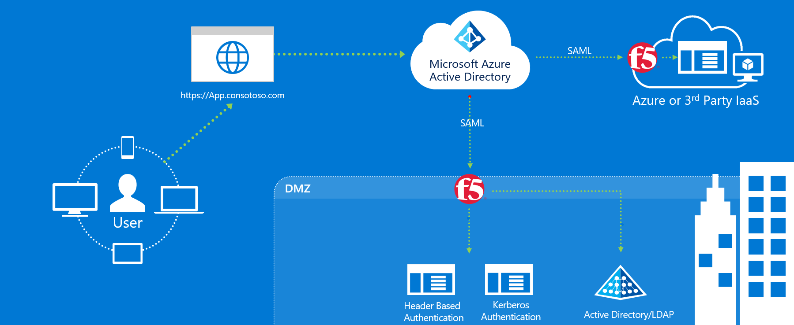

The Above Integration allows enterprises to leverage F5 with Azure AD to cover the both Modern authentication and header Authentication using Azure Active Directory as control Plane.

|  |  |  |
| --- | --- | --- |
| **PeopleSoft** | **Azure AD** | **F5 BIG-IP** |
| Header Based Authentication | SAML IDP - Azure Conditional Access / Identity Protection Services | SAML SP - Maps SAML Assertion to HTTP Headers for PeopleSoft Application consumption |

# Pre-requisites

1. Deploying the joint solution requires the following license:

* F5 BIG-IP® Best bundle (or)
* F5 BIG-IP Access Policy Manager™ (APM) standalone license
* F5 BIG-IP Access Policy Manager™ (APM) add-on license on an existing BIG-IP F5 BIG-IP® Local Traffic Manager™ (LTM).
* In addition to the above license, the F5 system may also be licensed with:
  + A URL Filtering subscription to use the URL category database
  + An F5 IP Intelligence subscription to detect and block known attackers and malicious traffic
  + A network hardware security module (HSM) to safeguard and manage digital keys for strong authentication

1. F5 BIG-IP system is provisioned with APM modules (LTM is optional)
2. Although optional, it is highly recommended to Deploy the F5 systems in a [sync/failover device group](https://techdocs.f5.com/kb/en-us/products/big-ip_ltm/manuals/product/big-ip-device-service-clustering-administration-14-1-0.html) (S/F DG), which includes the active standby pair, with a floating IP address for high availability (HA). Further interface redundancy can be achieved using the Link Aggregation Control Protocol (LACP). LACP manages the connected physical interfaces as a single virtual interface (aggregate group) and detects any interface failures within the group.

# Part 1: Setting up Azure Active Directory Integration

Select Enterprise Application Blade and add the “F5 BIG-IP APM Azure AD integration” from the gallery.

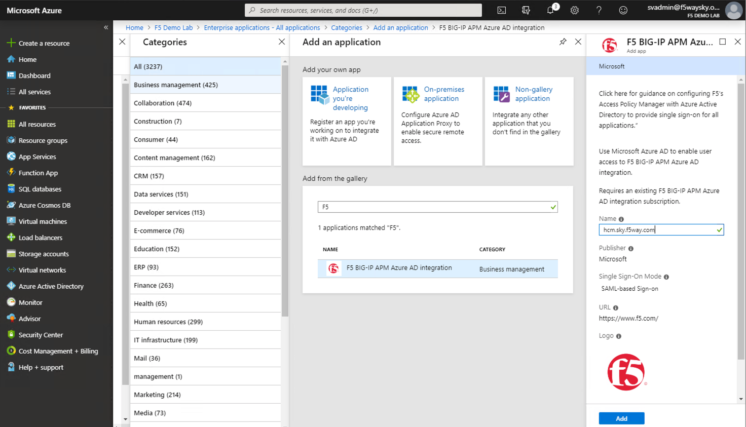

Navigate to the Users and Groups and Specify the users entitled for the PeopleSoft application.

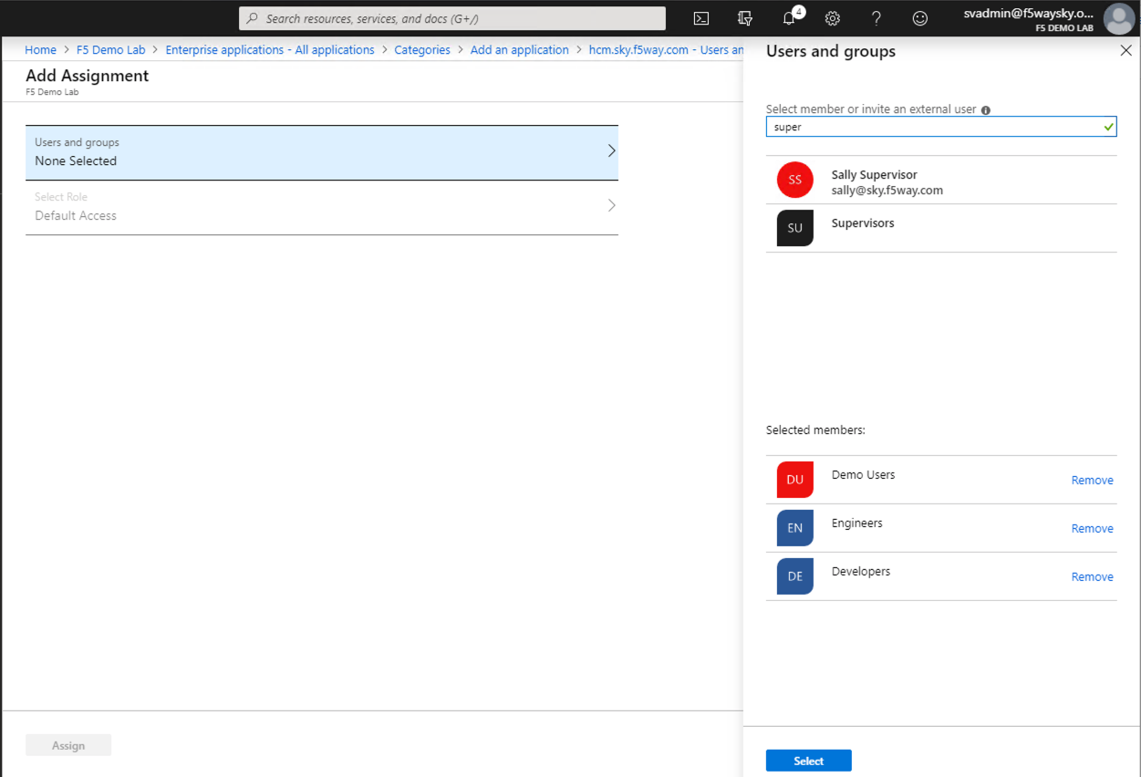

Specify SAML as the Single Sign-on method.

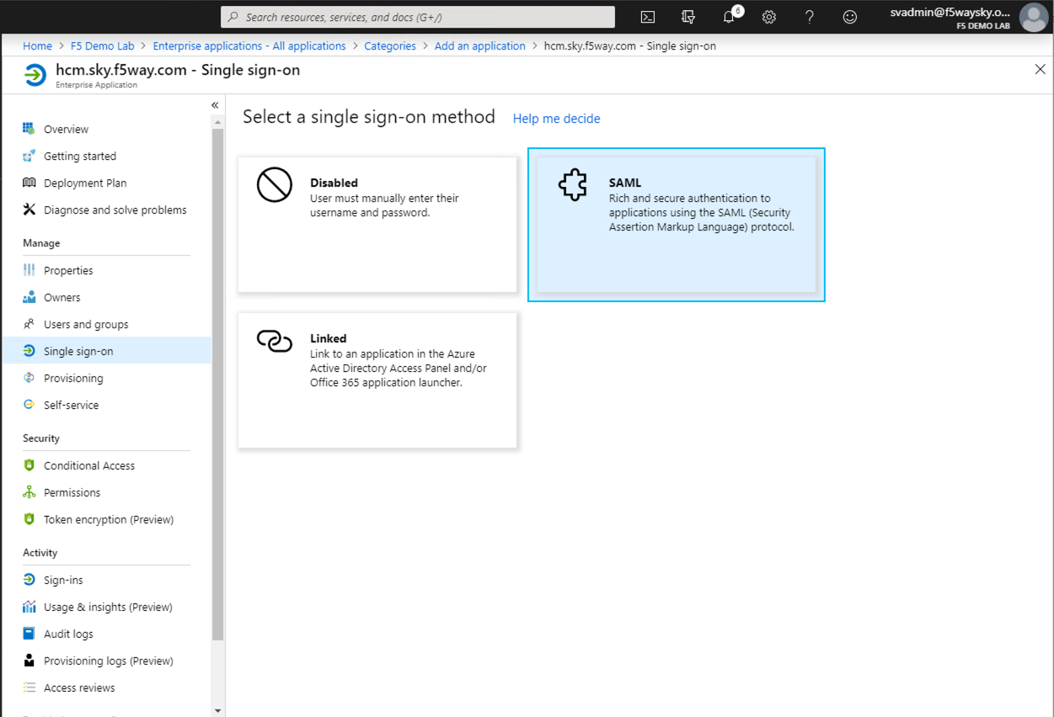

Complete the Basic SAML Configuration Section with the following settings:

* Identifier (Entity ID) = https://hcm.sky.f5way.com
* Reply URL = <https://hcm.sky.f5way.com/saml/sp/profile/post/acs>
* Logout URL = https://hcm.sky.f5way.com/saml/sp/profile/redirect/slr

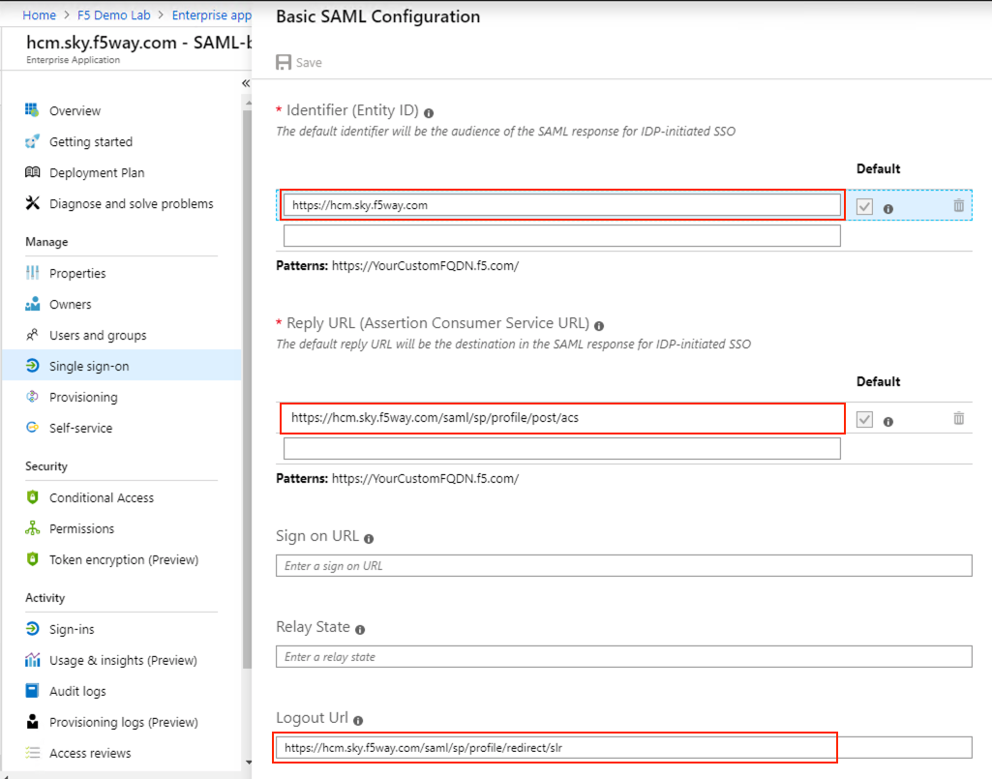

Customize claims issued in the SAML token for PeopleSoft application. Add new SAML attribute which is used as PeopleSoft User ID.

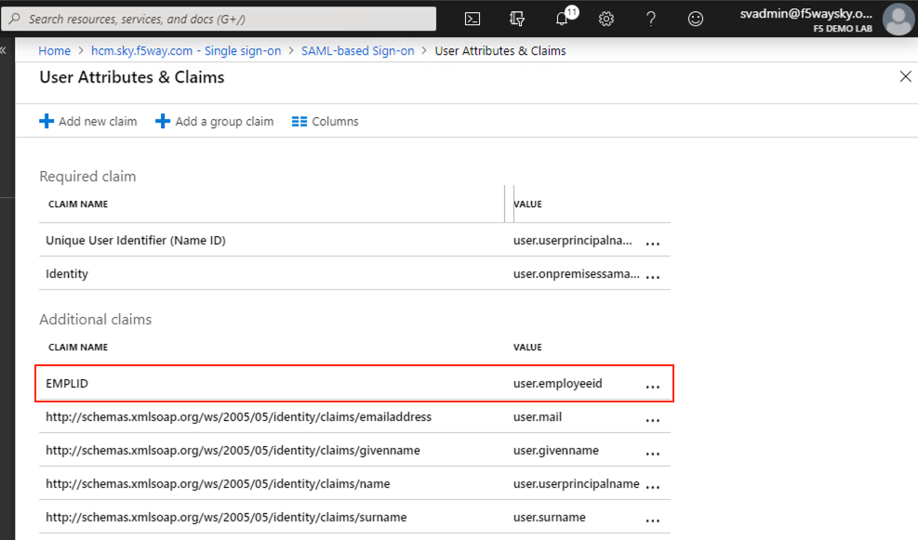

Download the Federation Metadata XML and the Certificate (Base64)

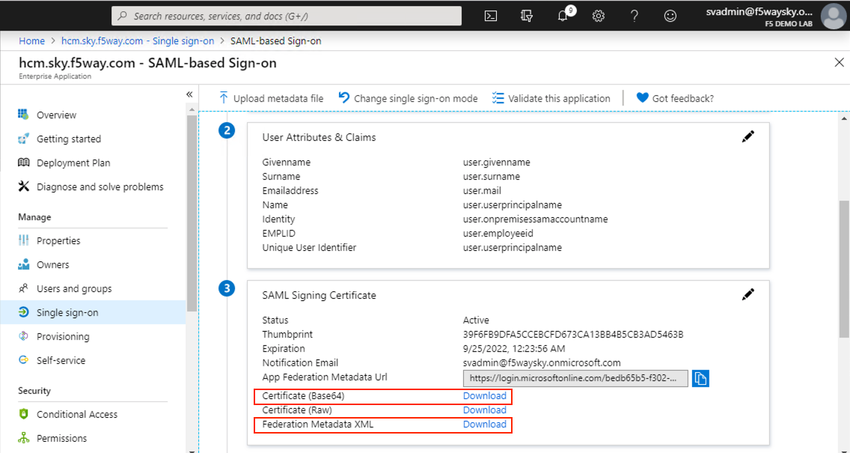

#### Note the following details from the XML file (Optional only for reference)

* entityID
* SingleLogoutService Location
* SingleSignOnService Location

Example:

* entityID="https://sts.windows.net/bedb65b5-f302-42f8-ac94-08bdc945152a/"
* SingleLogoutService Location="**https://login.microsoftonline.com/bedb65b5-f302-42f8-ac94-08bdc945152a/saml2**"
* SingleSignOnService Location="[**https://login.microsoftonline.com/bedb65b5-f302-42f8-ac94-08bdc945152a/saml2**](https://login.microsoftonline.com/bedb65b5-f302-42f8-ac94-08bdc945152a/saml2)"

# *Part 2:* F5 SAML SP Configuration

You will need to import the Metadata Certificate into the F5 which will be used later in the setup process. Navigate to **System > Certificate Management > Traffic Certificate Management > SSL Certificate List**. Select **Import** from the right-hand corner.

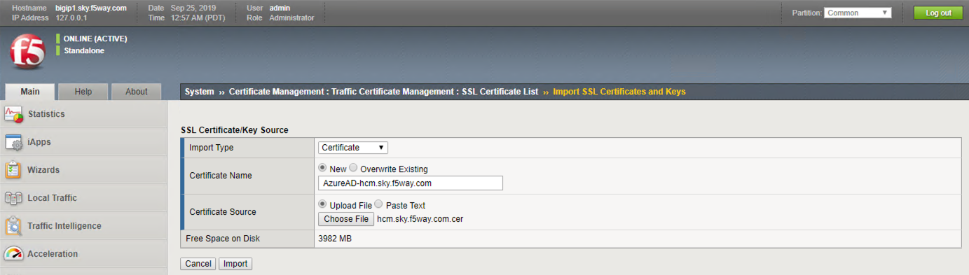

**Setup the SAML IDP Connector:**

Navigate to **Access > Federation > SAML: Service Provider > External Idp Connectors** and click **Create** > **From Metadata**.

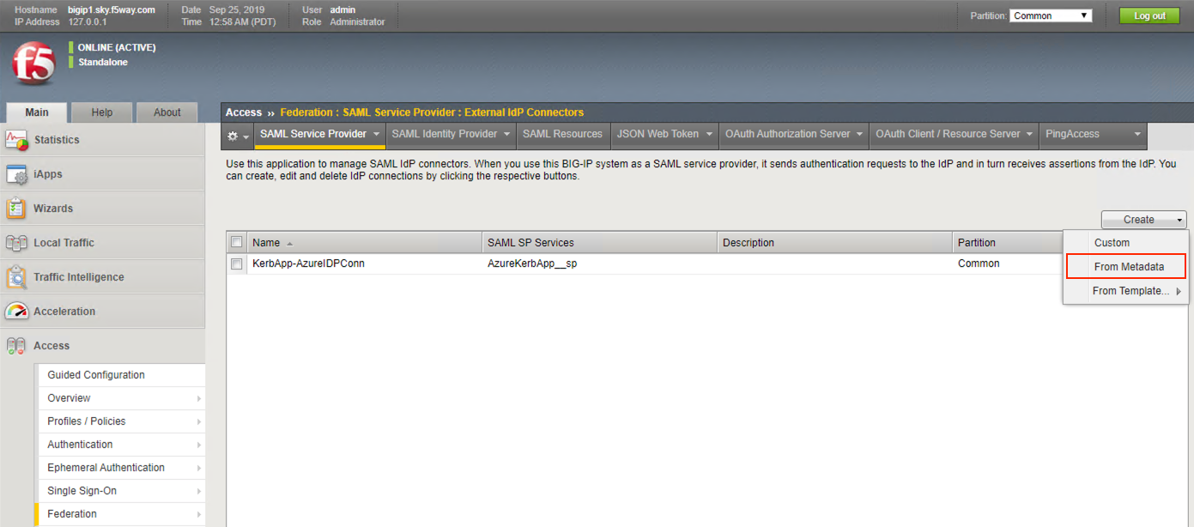

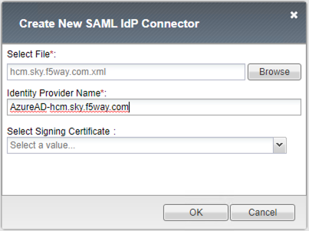

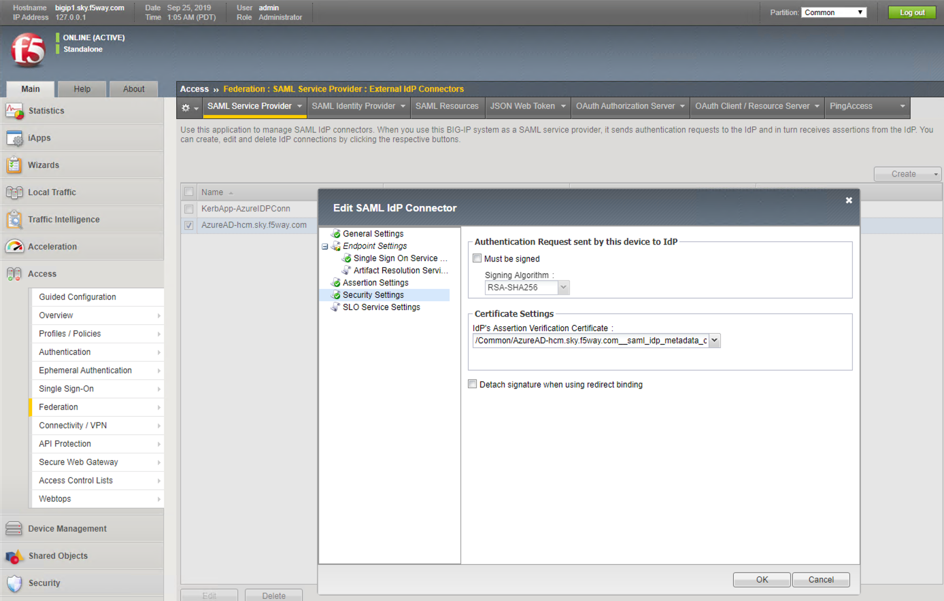

**Setup the SAML SP:**

Navigate to **Access > Federation > SAML Service Provider > Local SP Services** and click **Create**. Complete the following information and click **OK**.

* Name: PeopleSoftAppSSO
* Entity ID*: https://hcm.sky.f5way.com
* SP Name Settings
  + Scheme: https
  + Host: hcm.sky.f5way.com
  + Description: SP object for PeopleSoftAppSSO

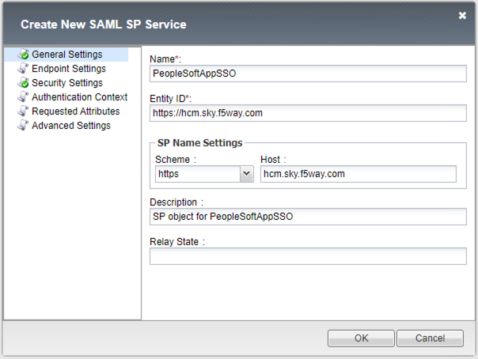

Select the SP Configuration, PeopleSoftAppSSO, and Click **Bind/UnBind IdP Connectors**.

Click on **Add New Row** and Select the **External IdP connector** created in previous step, click **Update**, and then click **OK**.

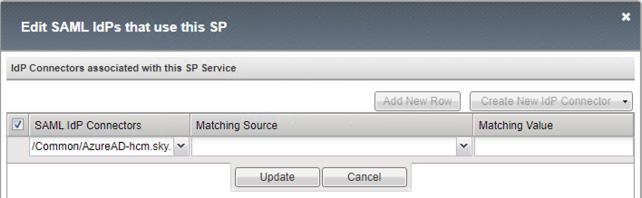

# Part 3: Configuring APM Access Profile

Navigate to **Access > Profile/Policies > Access Profile** (per session policies), click **Create**, complete the following information and click **Finished**.

* Name: PeopleSoftApp
* Profile Type: All
* Profile Scope: Profile
* Languages: English

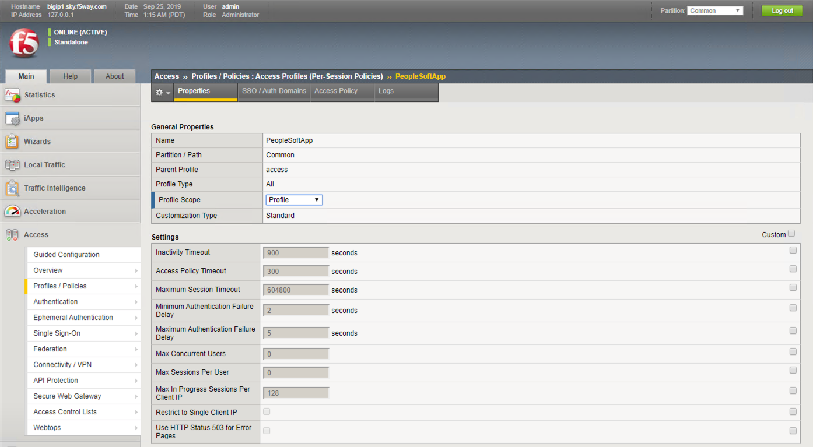

Click **Access Policy** and then click **Edit Access Policy** for Profile “PeopleSoftApp”

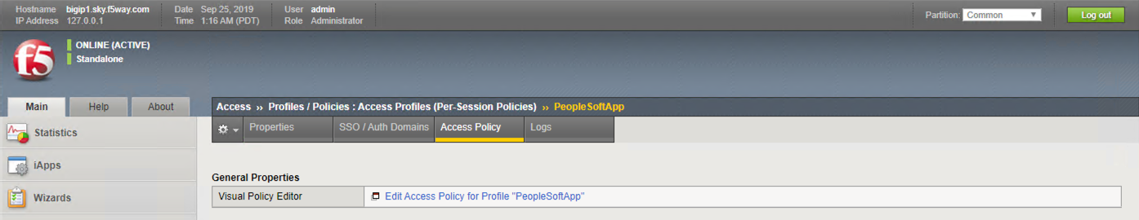

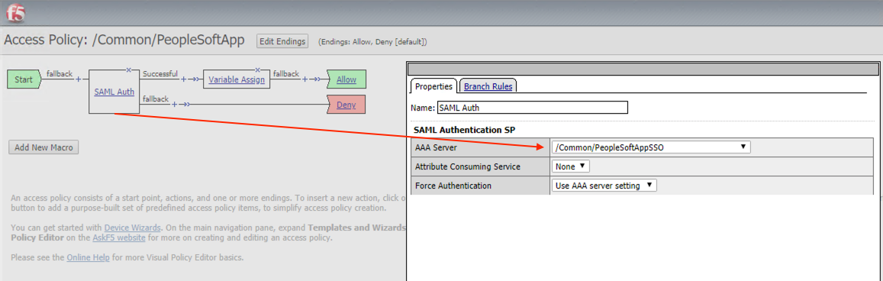

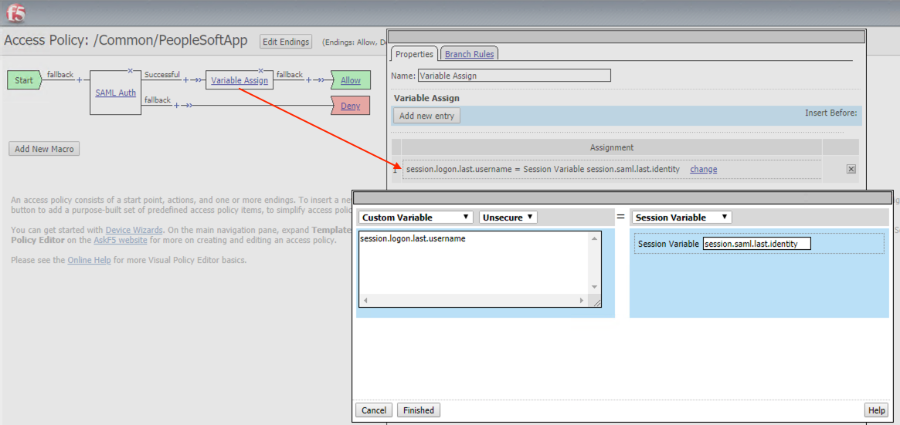

session.logon.last.username = mcget {session.saml.last.identity}

# Part 4: Configuring Application

**Create a new Pool**

Navigate to **Local Traffic > Pools > Pool List**, click **Create**, complete the following information and click **Finished**.

* Name: PeopleSoft-Pool
* Description: PeopleSoft-Pool
* Health Monitors: http
* Address: 10.10.10.10
* Service Port: 8000

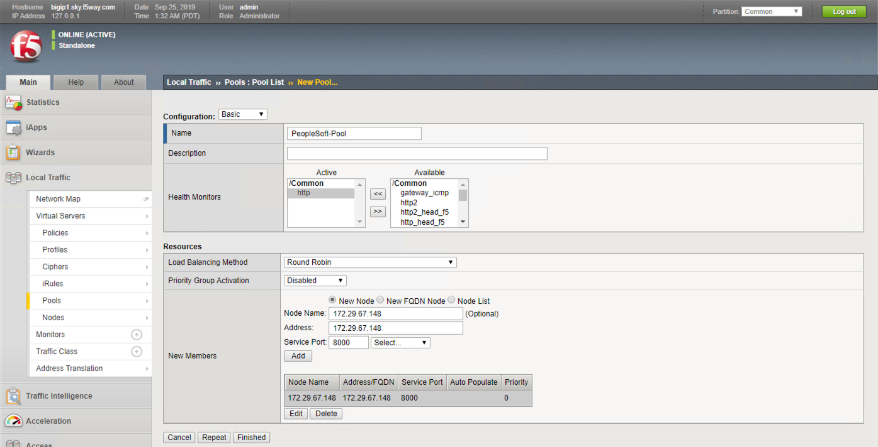

**Create a new Client SSL profile**

Navigate to Loca**l Traffic > Profiles > SSL > Client >** +, complete the following information and click **Finished**.

* Name: PeopleSoftApp-clissl
* Certificate: hcm.sky.f5way.com
* Key: hcm.sky.f5way.com

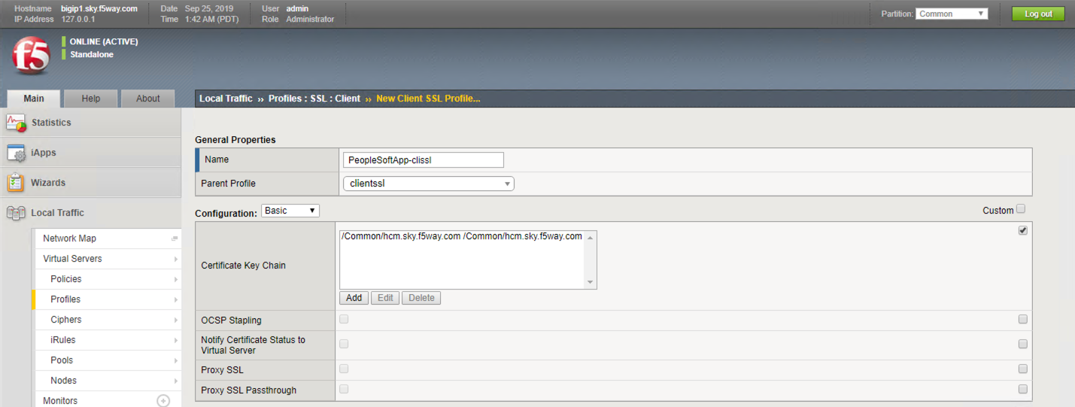

**Create a new Virtual Server**

Navigate to Loca**l Traffic > Virtual Servers > Virtual Server List >** +, complete the following information and click **Finished**.

* Name: PeopleSoftApp
* Destination Address/Mask: Host 10.10.10.32
* Service Port: Port 443 HTTPS
* HTTP Profile (Client): http
* SSL Profile (Client): PeopleSoftApp-clissl
* Source Address Translation: Auto Map
* Access Profile: PeopleSoftApp
* Default Pool: PeopleSoft-Pool

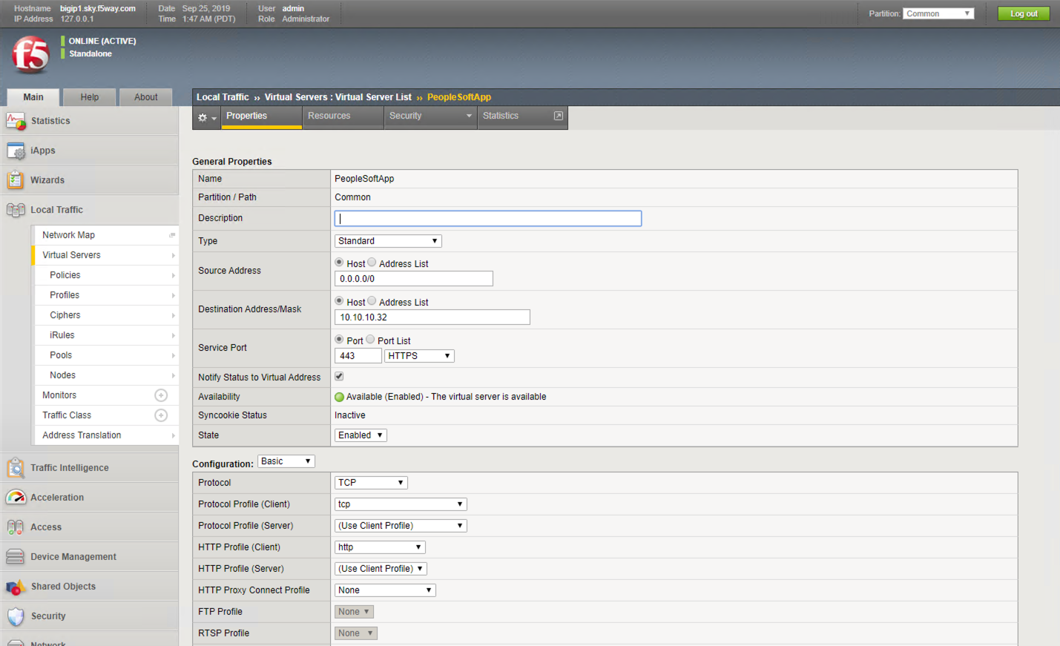

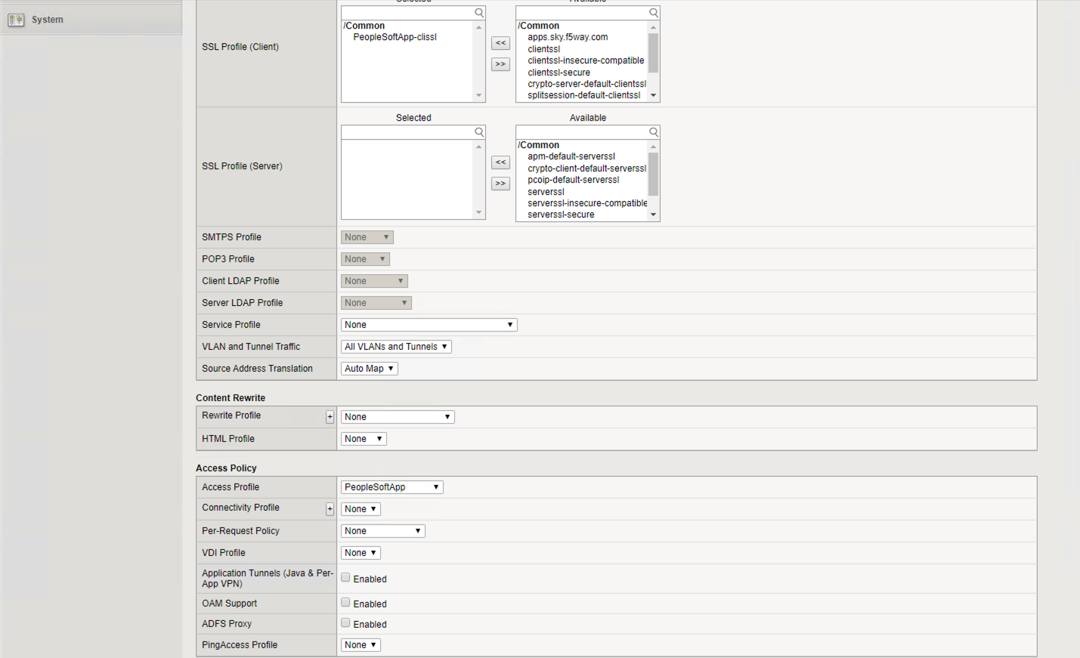

# Part 5. Setting up PeopleSoft application to support F5 Big-IP APM as the single sign-on solution

Note: Reference <https://docs.oracle.com/cd/E12530_01/oam.1014/e10356/people.htm>

**Step 1:** Logon to Peoplesoft Console http://hcm.sky.f5way.com:8000/psp/ps/?cmd=start using Admin credentials(Example: PS/PS)

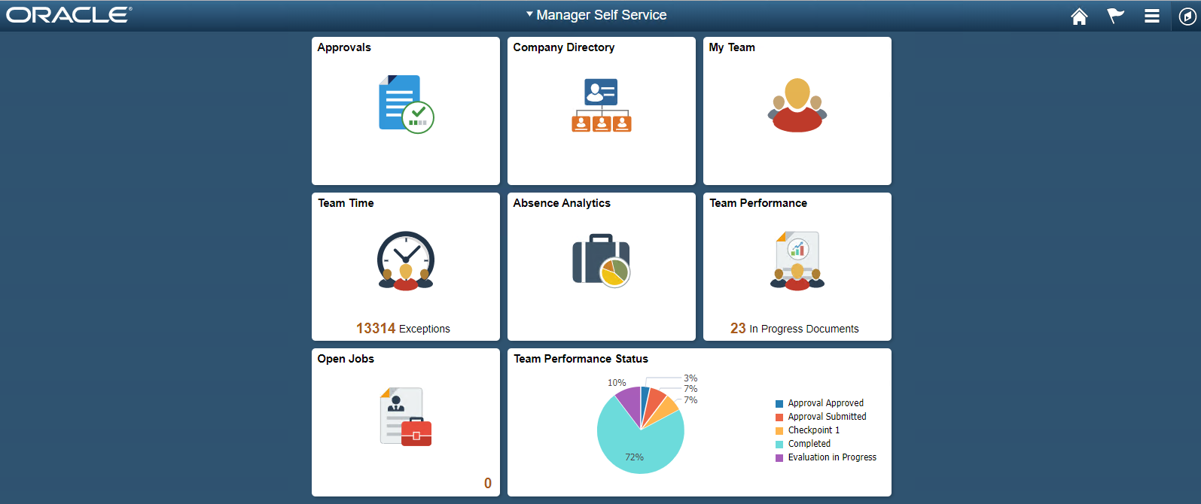

**Step 2:** In the PeopleSoft application, create ***OAMPSFT*** as a new user profile and associate a low security role such as ***PeopleSoft User***.

Navigate to **Peopletools >> Security >> User Profiles >> User Profiles** to create a new user profile, for example: **OAMPSFT** and Add **Peoplesoft User**.

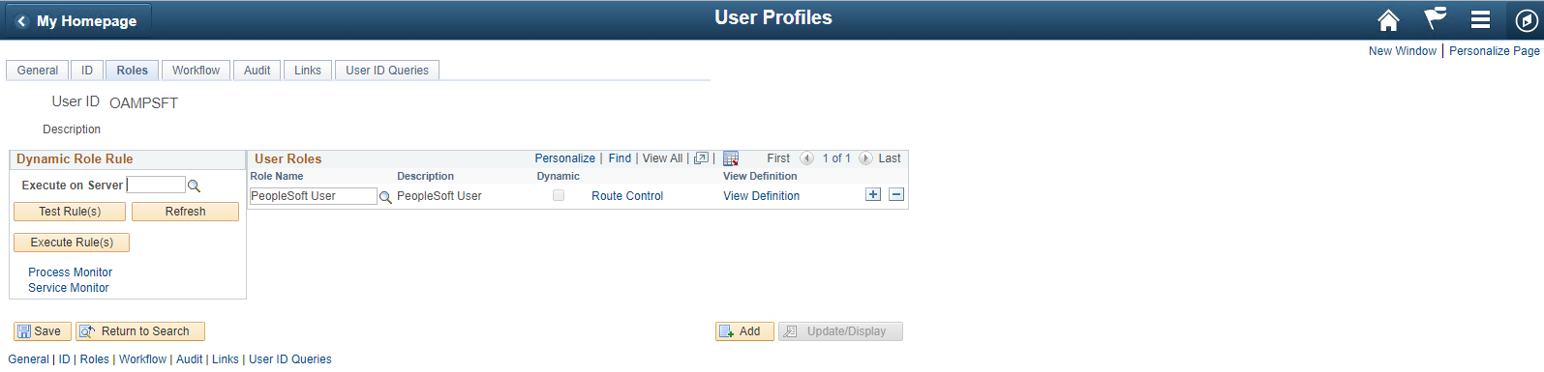

**Step 3:** Access the web profile and enter ***OAMPSFT***as the public access ***user ID***.

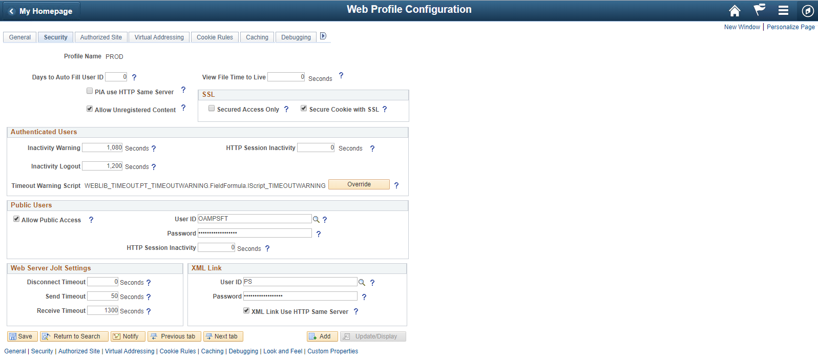

**Step 4:** From the **PeopleTools Application Designer**, open the **FUNCLIB_LDAP** record.

**Step 5:** Update the user Header with ***PS_SSO_UID*** for ***OAMSSO_AUTHENTICATION*** function.

In the ***getWWWAuthConfig()*** function, replace the value that is assigned to the ***&defaultUserId*** with the ***OAMPSFT*** that we defined in the Web profile. Save the record definition.

**Step 6:** Access the **Signon PeopleCode** page (PeopleTools, Security, Security Objects, Signon PeopleCode) and enable the ***OAMSSO_AUTHENTICATION*** function—the Signon PeopleCode for Oracle Access Manager single signon.

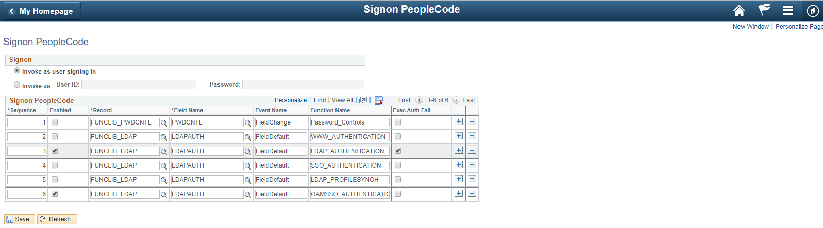

# Part 6. Setting up F5 Big-IP APM to populate “PS_SSO_UID” HTTP Header with the PeopleSoft User ID

#### **Configuring Per-Request Policy**

Navigate to **Access > Profile/Policies > Per-Request Policies**, click **Create**, complete the following information and click **Finished**.

* Name: PeopleSoftSSO
* Profile Type: All
* Languages: English

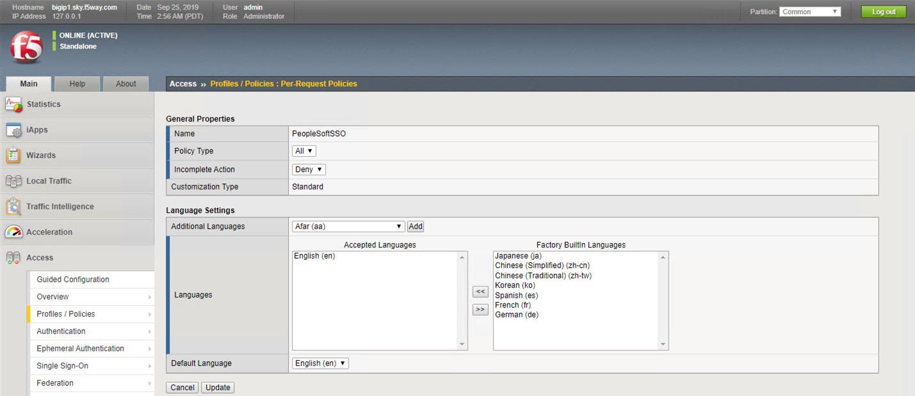

Click **Edit** Per-Request Policy “PeopleSoftSSO”

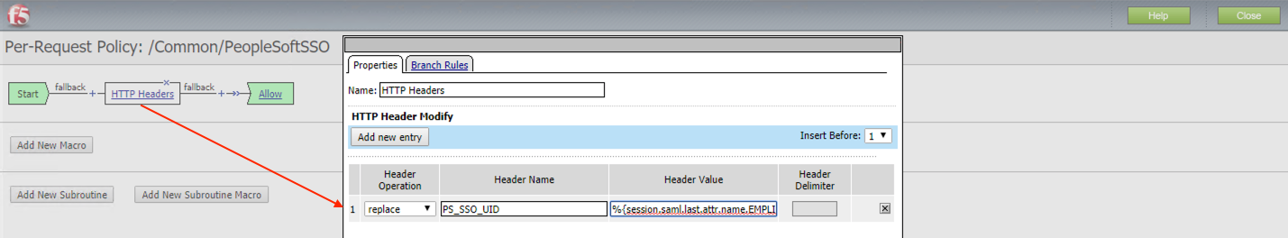

*Header Name: PS_SSO_UID*

*Header Value: %{session.saml.last.attr.name.EMPLID}*

#### **Assign Per-Request Policy to the Virtual Server**

Navigate to Loca**l Traffic > Virtual Servers > Virtual Server List > PeopleSoftApp**

Specify “PeopleSoftSSO” as Per-Request Policy

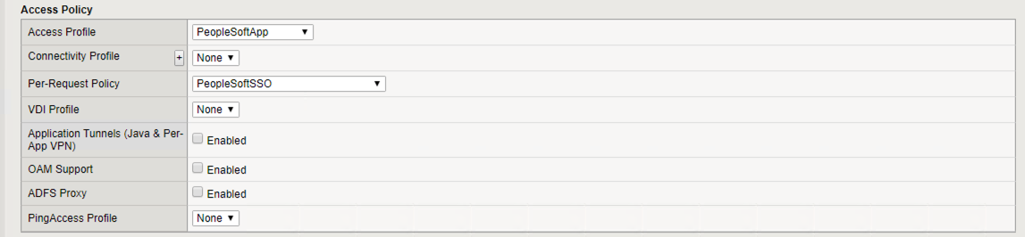

# Part 7. Setting up F5 Big-IP APM to support Single Logout from PeopleSoft application

If you want to add single logout support for all PeopleSoft users, you should follow these steps:

**Step 1:** Determine the correct logout URL for your PeopleSoft portal

To determine the address that your PeopleSoft application uses to end a user session, you need to open the portal using any web browser and enable browser debug tools, as shown in the example below:

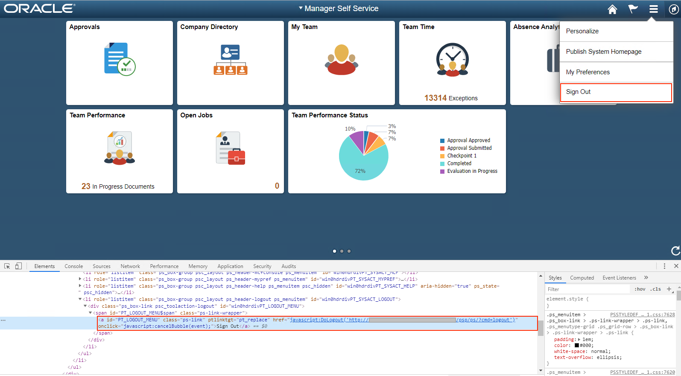

Find the element with the “*PT_LOGOUT_MENU*” id and save the URL path with the query parameters. In our example, we got the following value: *“/psp/ps/?cmd=logout”*

**Step 2:** Create LTM iRule that will redirect the user to the APM logout URL: "*/my.logout.php3*"

Navigate to **Local Traffic > iRule**, click **Create**, complete the following information and click **Finished**.

Name: _iRule_PeopleSoftApp

Definition:

*when HTTP_REQUEST {*

*switch -glob -- [HTTP::uri] {*

*“****/psp/ps/?cmd=logout****" {*

*HTTP::redirect "***/my.logout.php3***"*

*}*

*}*

*}*

**Step 3:** Assign the created iRule to the Virtual Server

Navigate to **Local Traffic > Virtual Servers > Virtual Server List > PeopleSoftApp > Resources.** Click the **“Manage…”** button**:**

Specify “_iRule_PeopleSoftApp” as Enabled iRule and click “**Finished**”

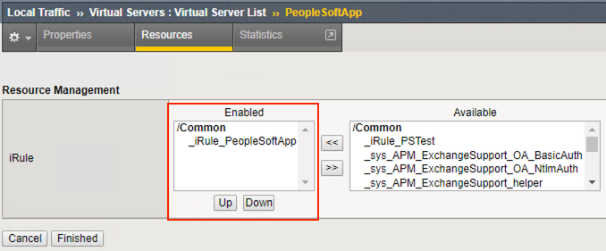

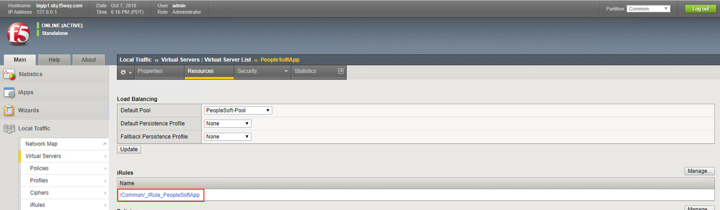

# Part 8 (Optional). Configure Big-IP APM to automatically redirect the user to the PeopleSoft portal URL.

This part is optional since the Big-IP should not introduce any features into the operation of the PeopleSoft application and this requirement should be resolved on the application side, however, you can quite simply set up redirections for your external users to an external Portal address.

In this case, we want to redirect all user requests from the root (“/”) to the external portal “/psc/ps/EXTERNAL/HRMS/c/NUI_FRAMEWORK.PT_LANDINGPAGE.GBL” URL.

**Step 1:** Create/Modify LTM iRule that will redirect all users’ requests to the external portal.

Navigate to Local Traffic > iRule, select “_iRule_PeopleSoftApp” and add addition URL:

*when HTTP_REQUEST {*

*switch -glob -- [HTTP::uri] {*

*"****/****" {*

*HTTP::redirect “****/psc/ps/EXTERNAL/HRMS/c/NUI_FRAMEWORK.PT_LANDINGPAGE.GBL****"*

*}*

*“****/psp/ps/?cmd=logout****" {*

*HTTP::redirect "***/my.logout.php3***"*

*}*

*}*

*}*

**Step 2:** Assign the created iRule to the Virtual Server

Navigate to **Local Traffic > Virtual Servers > Virtual Server List > PeopleSoftApp > Resources.** Click the **“Manage…”** button:

Specify “_iRule_PeopleSoftApp” as Enabled iRule and click “**Finished**”





# Appendix

## SAML – F5 BIG-IP Variable mappings

